Vidzeme University of Applied Sciences

**Faculty of Engineering**

Web Technologies and Secure Websites

Viesturs Karlivāns

practical work #4

Valmiera, 2025

1 Project Overview 4

1.1 Description of the chosen website topic. 4

1.2 Why Chose This Topic 4

1.3 Target Audience and Purpose 4

2 Design & Development Process 4

2.1.1 Setup and Initial Configuration 4

2.1.2 Content Structure and Page Creation 6

2.1.3 Posts and Media 8

2.1.4 Customisation and Design 11

2.1.5 Plugins and Functionality (Optional) 13

3 List of used resources 15

|  |  |  |  |
| --- | --- | --- | --- |
| Document versions | | | |
| Version | Status / Changes | Date | Author |
| 1.0 | Final version | 14.05.2025 | Viesturs Karlivāns |
|  |  |  |  |
|  |  |  |  |
|  |  |  |  |

|  |  |  |  |
| --- | --- | --- | --- |
| Contacts and responsible (-s) | | | |
| Name Surname | Department | Position | Contact information (e-mail) |
| Viesturs Karlivāns | Individual work | Member | [viesturs.karlivans@va.lv](mailto:Viesturs.Karlivans@va.lv) |
|  |  |  |  |
|  |  |  |  |
|  |  |  |  |
|  |  |  |  |

# Project Overview

## Description of the chosen website topic.

Short portfolio

## Why Chose This Topic

Homework about wordpress using.

## Target Audience and Purpose

**Target Audience:** IT companies

**Purpose:** companies who are searching developers and also if I am searching work, I can show this portfolio.

# Design & Development Process

### Setup and Initial Configuration

I choose WordPress instaltation locally, and sign up. Mamp is used as local server, where in folder htdocs unzipped the WordPress files. Also used mysql in phpMyAdmin and for email delivery used platform mailtrap.io Theme is about portfolio where I configured basic settings. Added pictures belove:

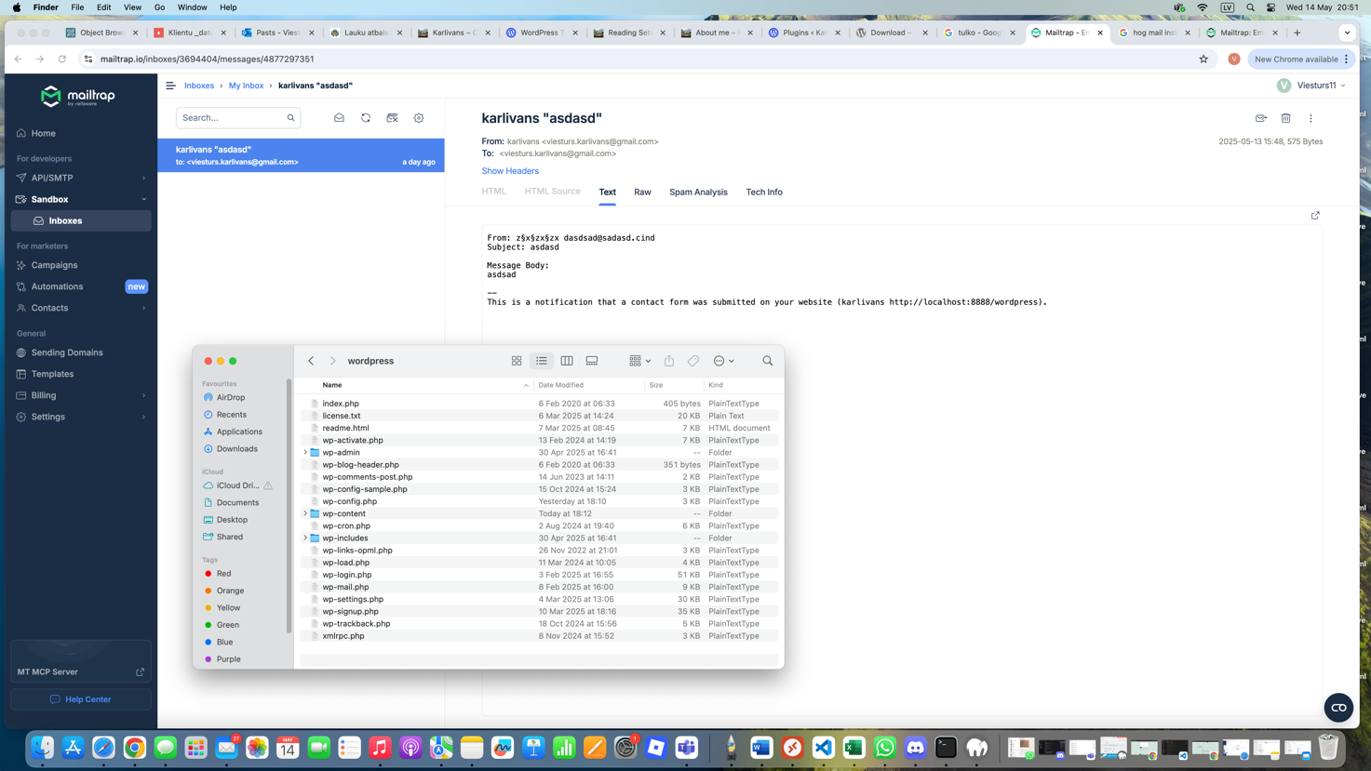

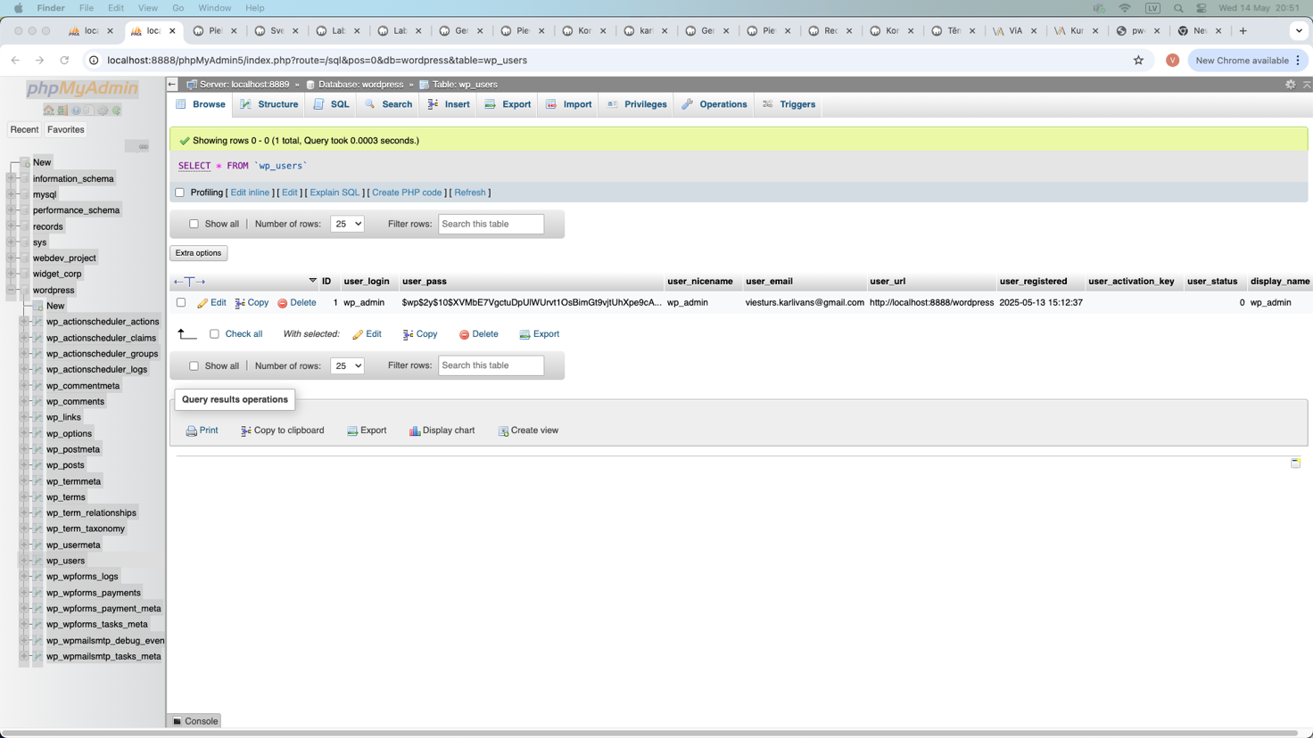

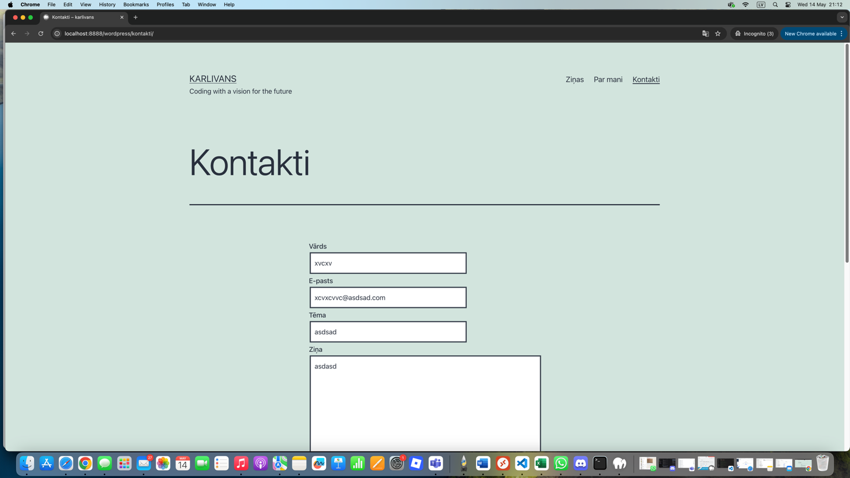

### Content Structure and Page Creation

Created the following pages:

* Home

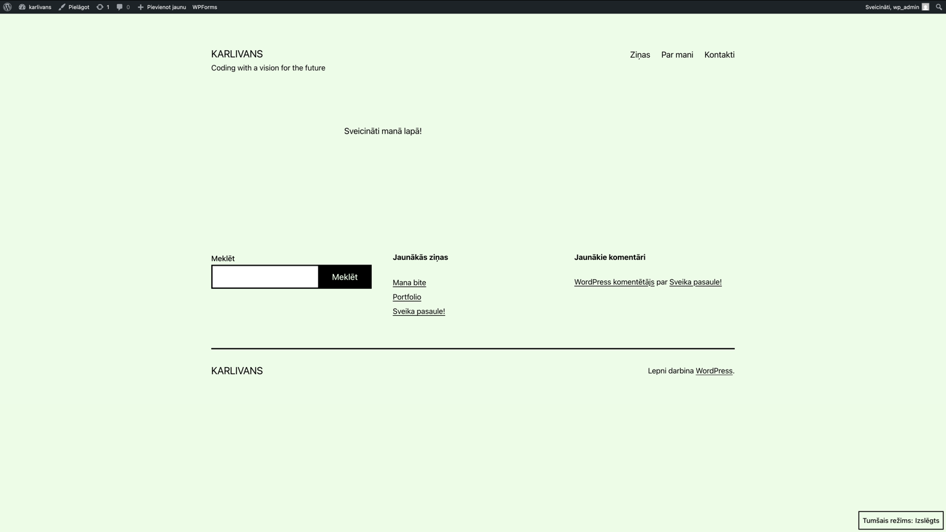

* About Me/Par mani

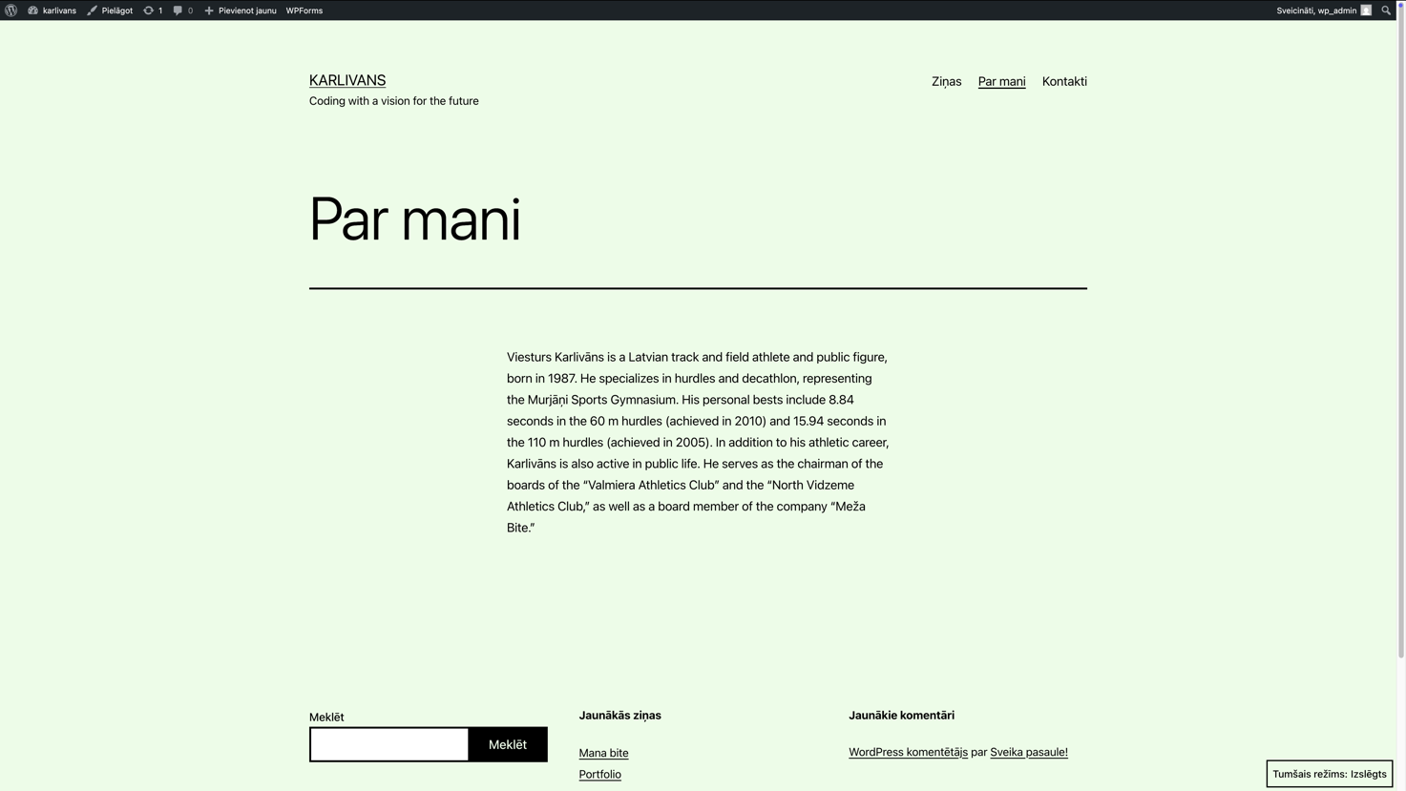

* Portfolio or blog/Ziņas

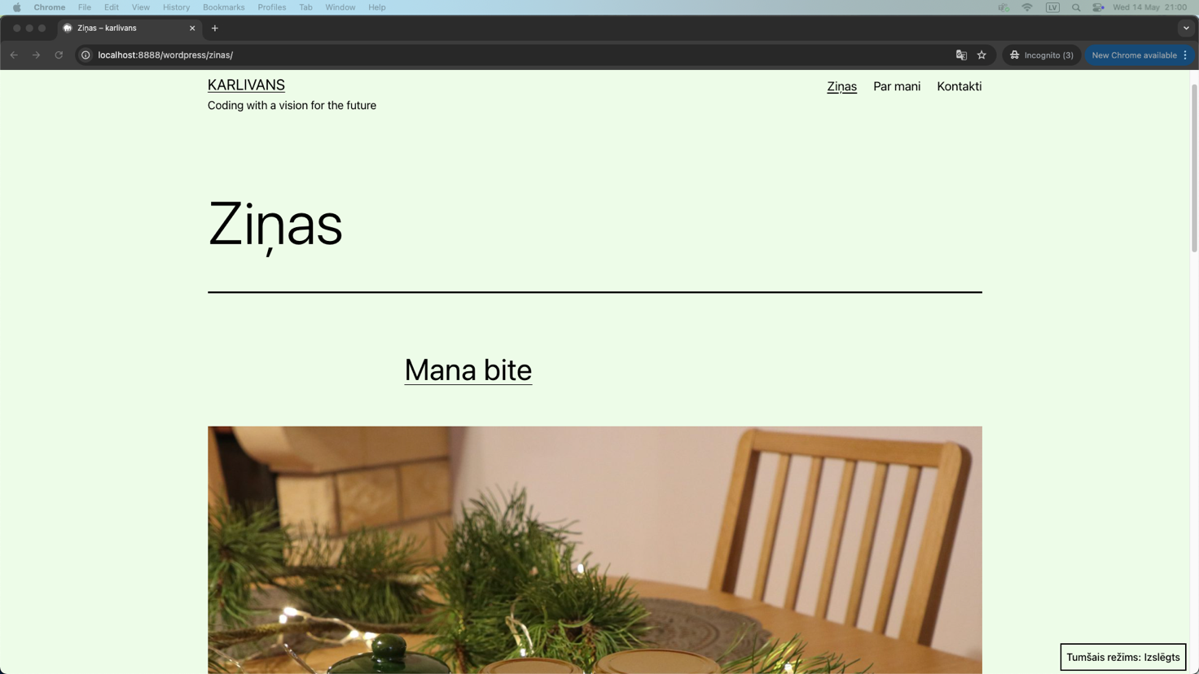

* Contact/Kontakti

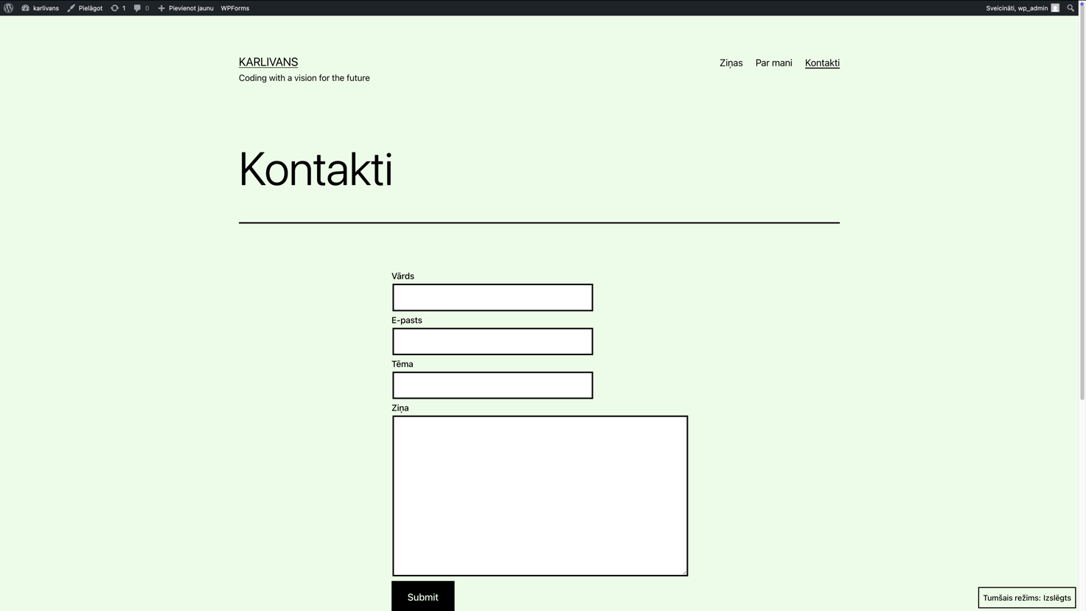

In pictures above can see that page is organized using menu editor.

### Posts and Media

* Create at least 3 blog posts (if doing a blog) OR create at least 3 portfolio items (if doing a portfolio site). From bouth I made News/Ziņas, where is picture below, you can see them.

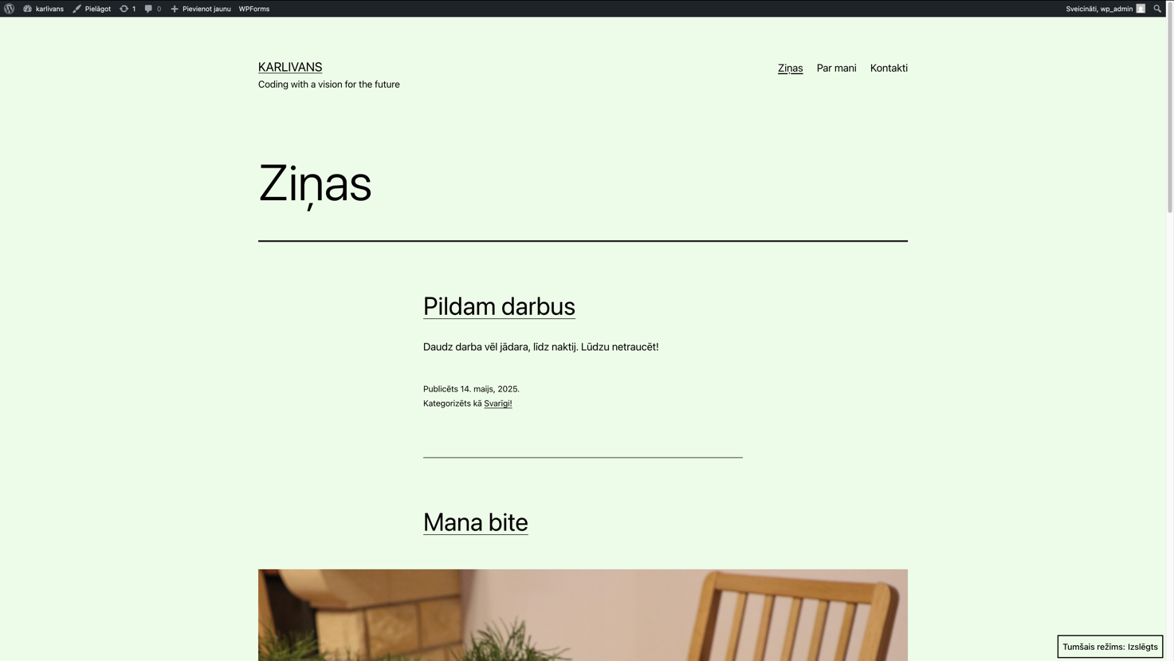

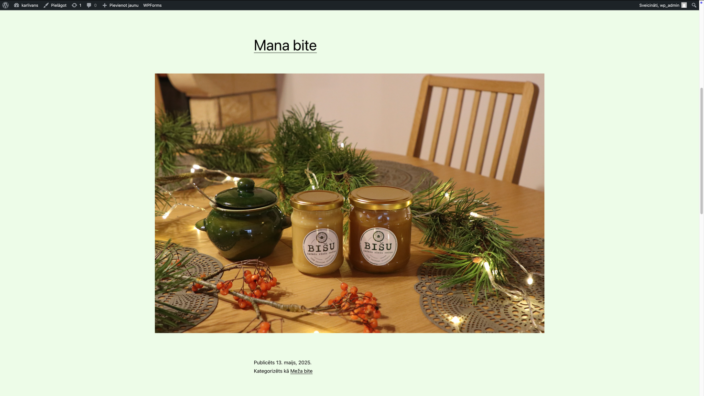

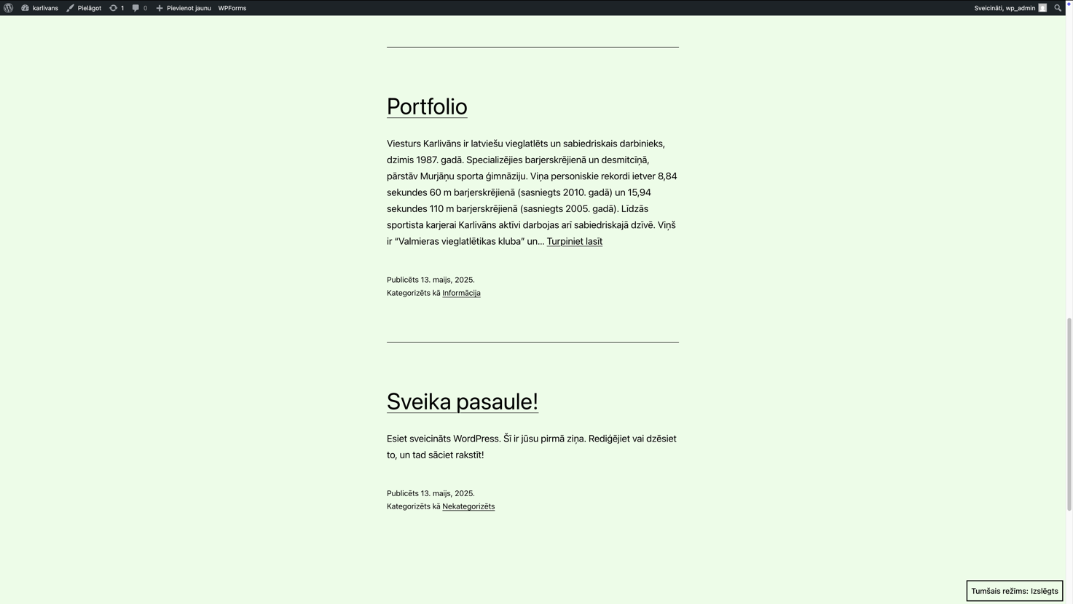

* In pictures above is used featured image and for categorise/tag your posts proper can see Kategorizēts kā informācija, Meža bite, Svarīgi!
* Embed media content (images, videos, etc.) As shown in the images below, I have embedded media content (an video) into the Ziņas

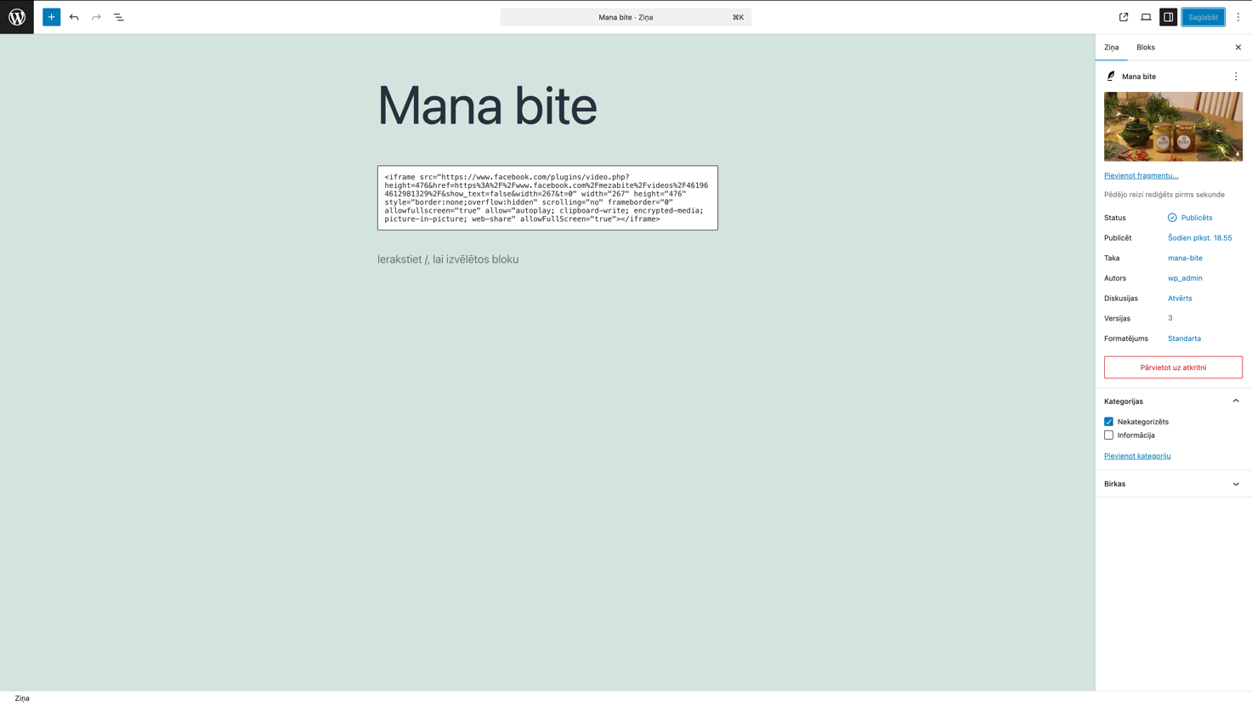

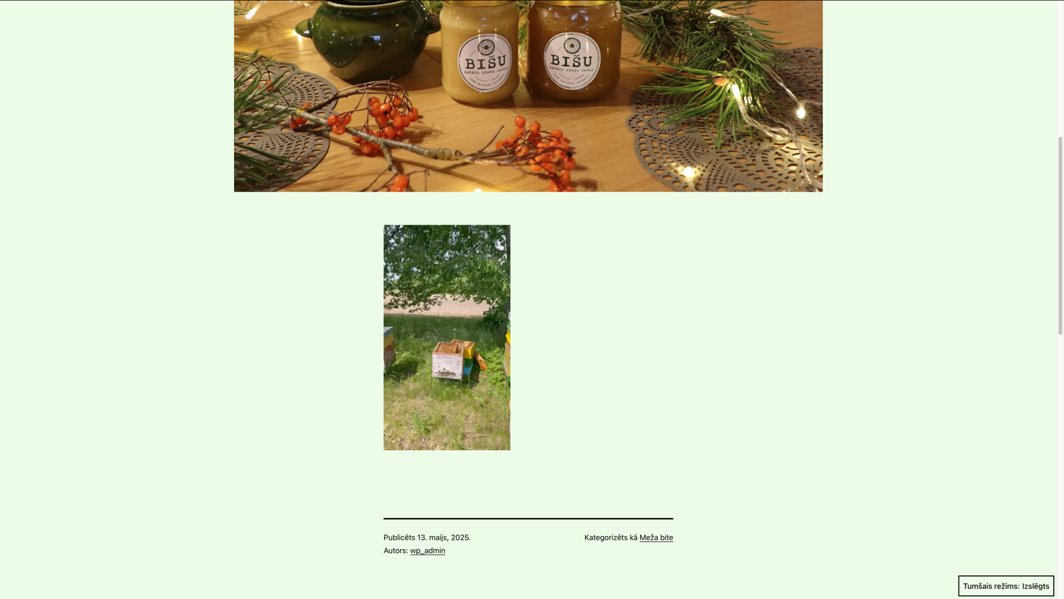

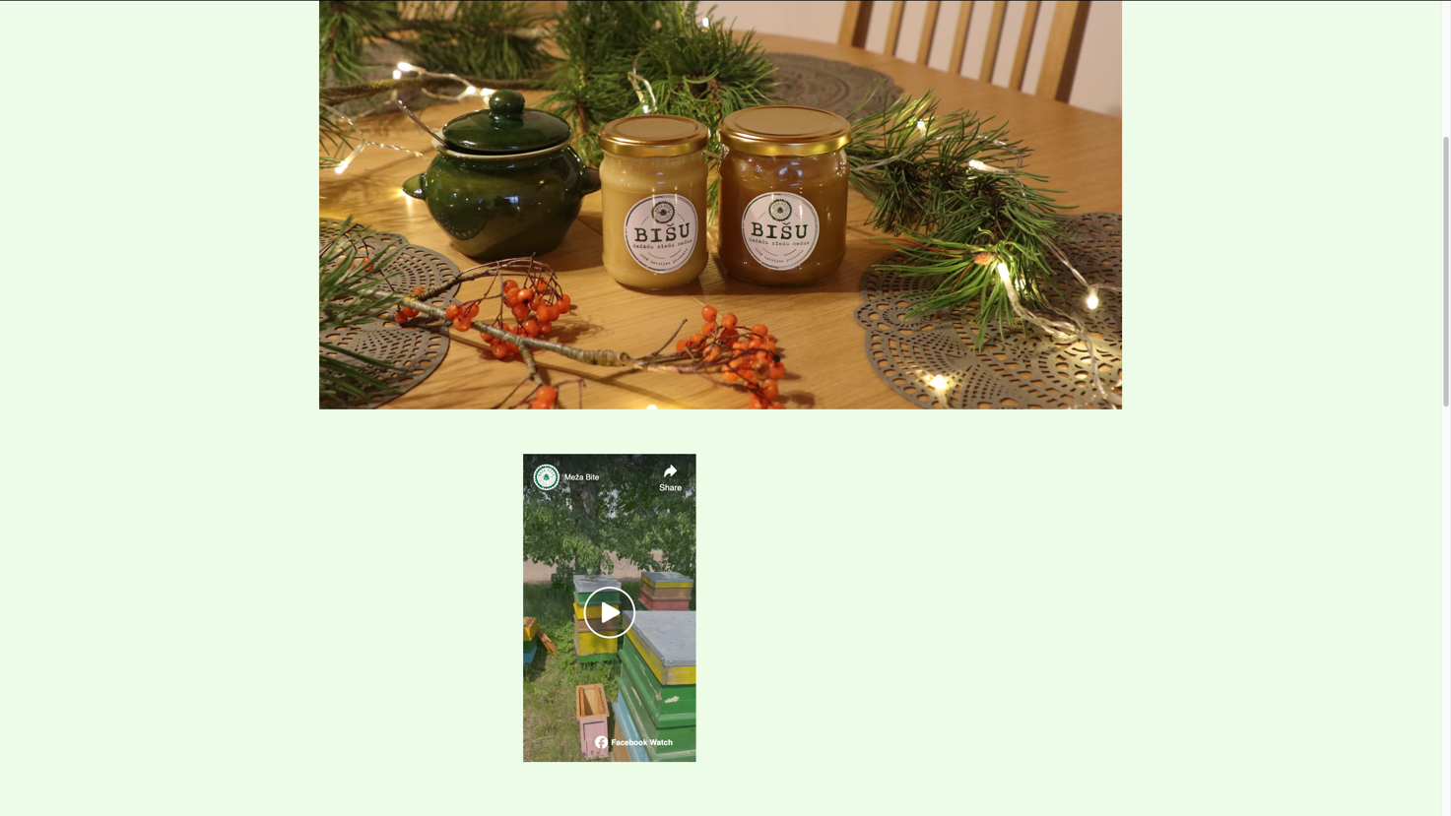

### Customisation and Design

Customise the theme using:

* Theme Customizer
* Widgets and Menus
* Header and Footer settings

4.2. Modify colours, typography, and layout to match your personal branding.

In these tasks I customised the Twenty Twenty-One theme using the Theme Customizer: slightly changed the background colour and updated the site tagline in the header ("Coding with a vision for the future") and modified typography by applying bold and italic styles to text elements. I also edited the main menu (Ziņas, Par mani, Kontakti), and removed one default widget that didn’t fit my needs. Additionally, I added a search widget and adjusted the footer layout. All changes are visible in the attached screenshots.

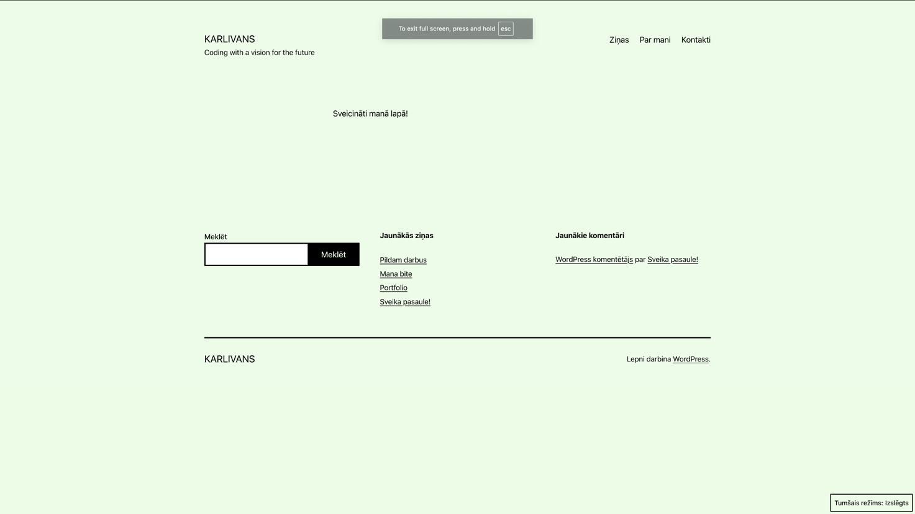

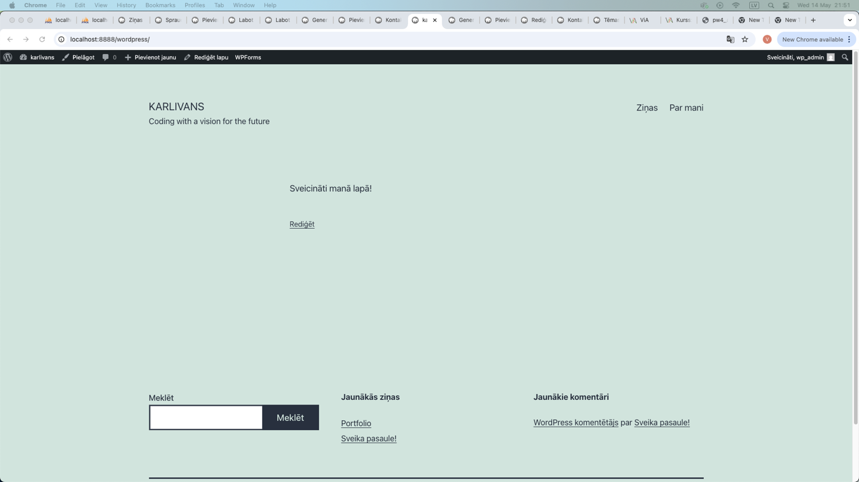

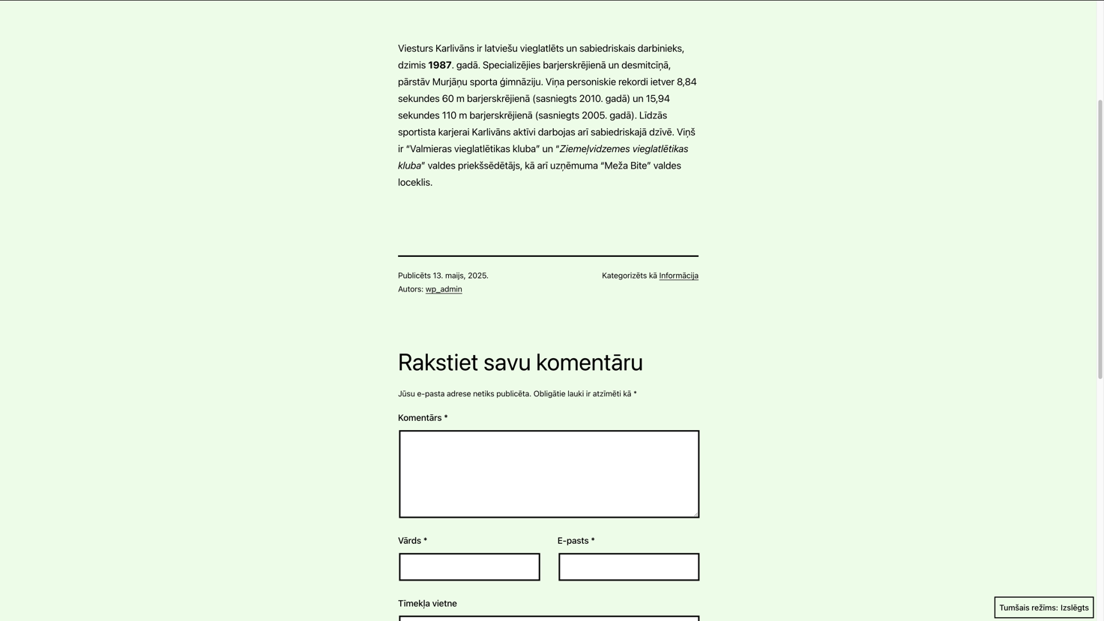

### Plugins and Functionality (Optional)

5.1. Install and configure at least 2 different plugins to extend your site’s functionality. Examples:

* Contact Form (e.g., WPForms, Contact Form 7)
* Gallery or Slider Social Media Integration

5.2. Provide a short explanation of each plugin’s use in your documentation. In pictures below: I chose WPForms to easily create a simple and user-friendly contact form. It allows visitors to get in touch directly through the website by submitting their name, email, subject, and message. This plugin is beginner-friendly, integrates well with WordPress, and is ideal for basic contact needs without coding. As the second plugin, I chose WP Mail SMTP after researching what could logically integrate with a contact form. It ensures that emails sent from the form are delivered correctly. During development, I used it together with Mailtrap to safely test email functionality without sending real messages. This plugin is essential when working with forms to avoid mail delivery issues and to simulate email behavior in a development environment.

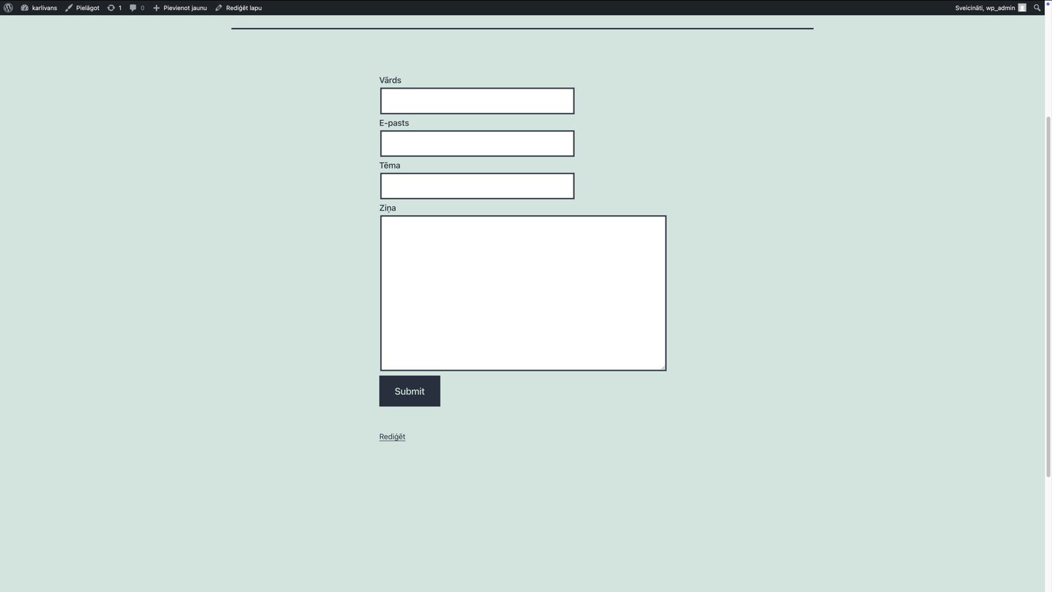

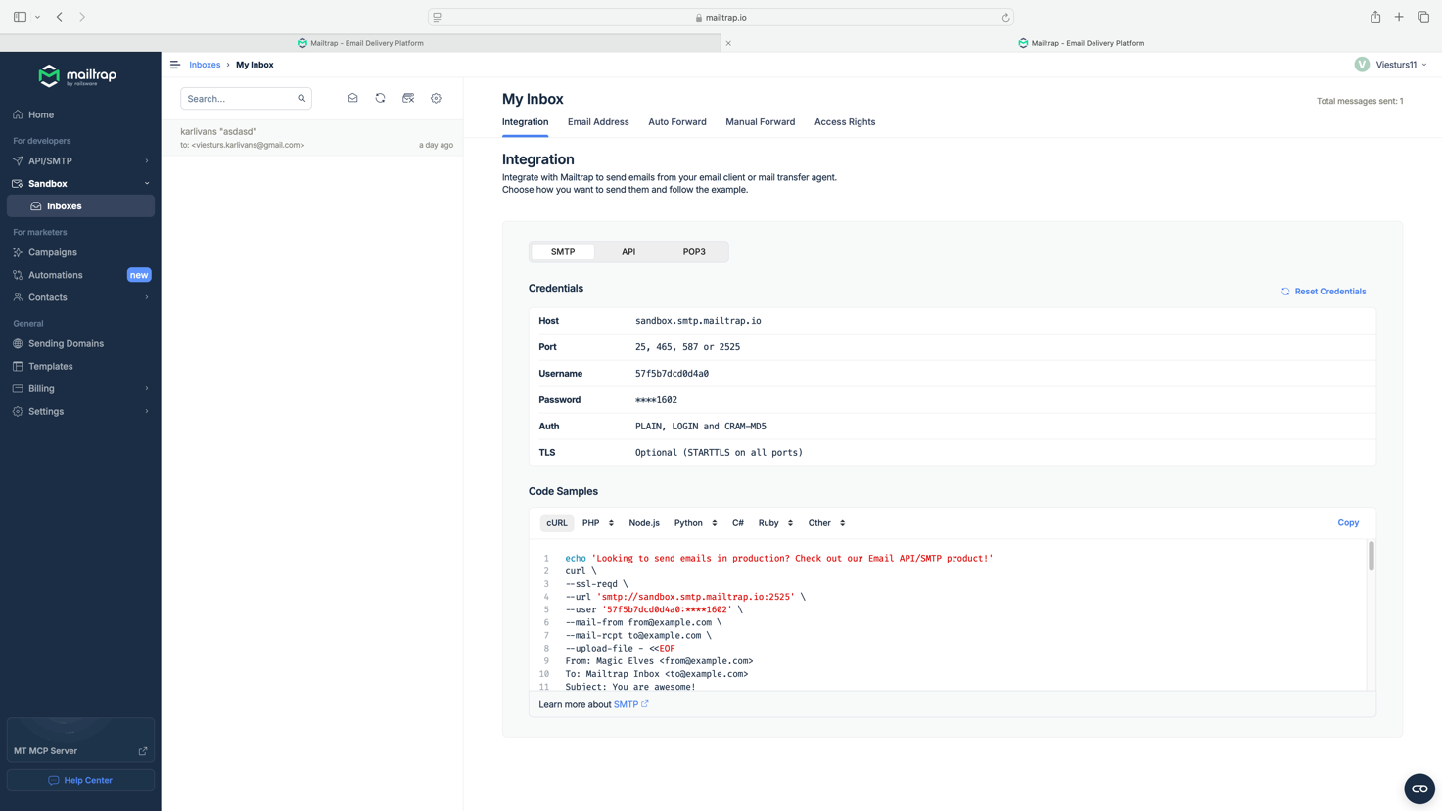

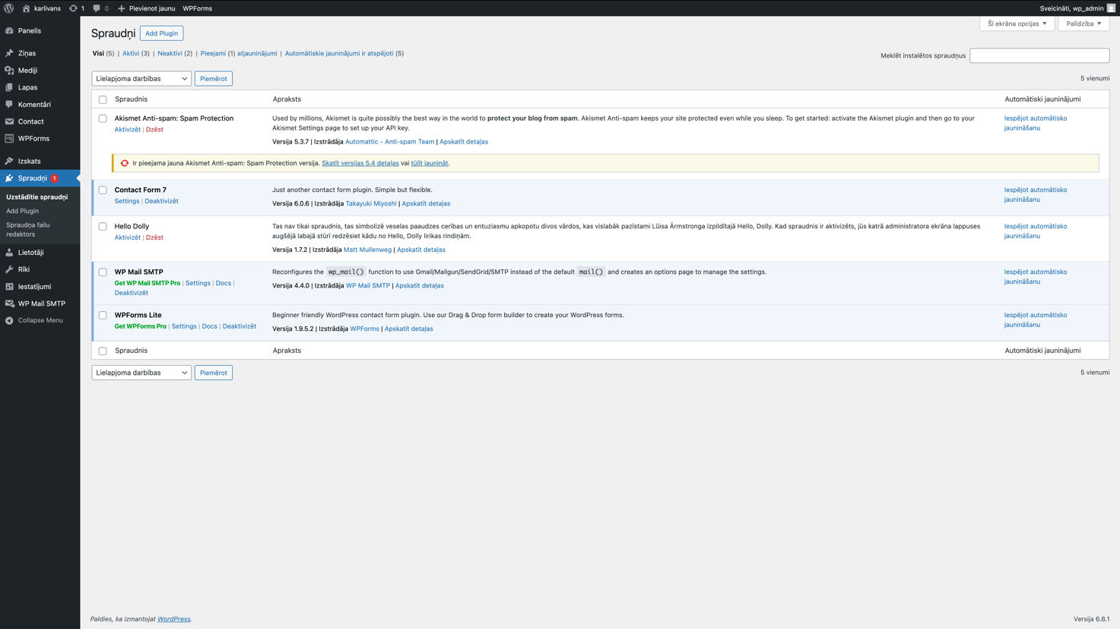

# List of used resources

* https://moodle.va.lv/pluginfile.php/80590/mod_resource/content/1/pw4_assignment_web_it2025.pdf
* <https://moodle.va.lv/course/view.php?id=1027>